Code -

> table((trial$`number of conservation agreements`))

0 1 2 3 4

31 36 15 1 1

partner

<- (trial$`total number of partners for species`)

> summary(partner)

Min. 1st Qu. Median Mean 3rd Qu. Max.

0.000 0.000 2.000 5.222 7.000 53.000

> table(partner)

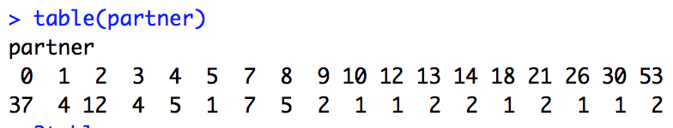

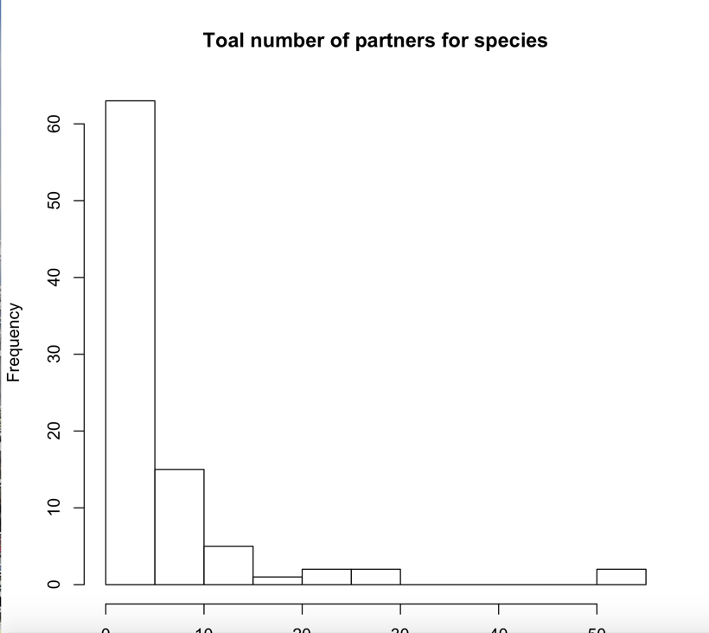

Type of agreements

(first column)

1 ? 1

2 A Partners Program 15-year Wildlife Habitat Enhancement Agreement 1

3 CCA 21

4 CCAA 6

5 Conservation Agreement 6

6 Conservation Assessment 1

7 Conservation Plan 1

8 Federal Listings 1

9 HCP 7

10 Lower Colorado River Multi-Species Conservation Plan 1

11 MOU 3

12 no docs 3

13 None 24

14 Recovery Plan 2

15 Report 1

16 USDA Forest Service Land and Resource Management Plan for National Forests in Florida 1

See code for who the partners are (some errors that I don’t know how to fix)

Notes:

* Current spreadsheets
  + “partnershipspecies_forR” Copy of data set that started with
    - Has notes on what different columns are doing
  + “trial” added notes
  + “rfftrial” – main data set with cleaned data
  + “dataforloopattempt” re-combined colums and kept terms separated by “,”

A list of columns used (notes on what each category means found under “partnershipspecies_forR”

|  |  |  |  |
| --- | --- | --- | --- |
| notes_all_cleaning specific | number of conservation agreements | total number of partners for species | type of agreements (source of information) |

|  |  |  |  |  |  |
| --- | --- | --- | --- | --- | --- |
| "in cooperation" (included in total unless stated otherwise) or other vague terms | List agency office (if given) | unspecified additional landowners | If distinction between species specific partners and total agreement partners, list total agreement partners here | note redundancy | Who the partners are |

Other

* Questions on missing documents
* Planning to use skolaski’s paper to set as standard?